DIRECT EXPANSION SYSTEMS (DX) MARINE AIR CONDITIONING SYSTEM
INTRODUCTION
There are two types of central air conditioning systems: Direct Expansion (DX) and Chilled Water. The air utilized to cool the room or space in the DX system is immediately routed across the refrigeration plant's cooling coil. In the case of a chilled water system, the refrigeration equipment chills the water first, then chills the air utilized to cool the rooms or spaces. Both of these systems have been thoroughly examined.

TYPE OF CENTRAL AIR CONDITIONING PLANT: DIRECT EXPANSION (DX)
The air used for cooling space in direct expansion or DX air central air conditioning plants is directly cooled by the refrigerant in the cooling coil of the air handling unit. The cooling efficiency of DX plants is better since the refrigerant cools the air directly. However, because it is not always practicable to carry refrigerant piping over long distances, direct expansion or DX central air conditioning systems are commonly employed to cool small buildings or single-story rooms. The DX type of central air conditioning systems have three primary compartments.
- The Plant Room
The compressor and condenser, two crucial components of the refrigeration system, are housed in the plant room. The compressor can be hermetically sealed or open. The air blasted by the fan cools the semi-hermetically sealed compressors, whereas the open type compressors are cooled by water. The open compressor can be driven directly from the motor shaft via a coupling or via a pulley system. Water cools the condenser, which is made up of shell and tube. The refrigerant runs along the tube side of the condenser while water flows along the shell side, allowing for faster refrigerant cooling. The water that cools the compressor and condenser is chilled in the cooling tower at the top of the building.
- The Air Handling Unit Room
The refrigerant exiting the plant room's condenser passes through a thermostatic expansion valve before entering the air handling unit, which is housed in a separate room. The evaporator or cooling coil, air filter, and a huge blower make up the air handling unit, which is a large box kind of equipment. The refrigerant enters the cooling coil after exiting the thermostatic expansion valve, where it cools the air entering the conditioned space. The DX central air conditioning system's evaporator is a coil-type evaporator with fins to improve heat transfer efficiency from the refrigerant to the air. The air handling unit has two types of ducts: one for absorbing hot return air from the rooms and the other for supplying chilled air to the rooms that need to be cooled. The air handling unit's blower allows it to capture hot return air that has absorbed heat from the room via the ducts. After that, the air is routed through the filters and over the cooling coil. The chilled air is then circulated through ducts to the rooms that need to be cooled.
- Air Conditioned Room
This is the area that needs to be cooled. It can be a private room, a hotel room, a portion of an office, or any other suitable application. The air handling room's ducts are routed to all of the rooms that need to be cooled. The grills or diffusers that feed the cooled air to the room are connected to the ducts. The air absorbs the heat and becomes heated before passing through a second set of grills and into the return air duct, which leads to the air handling unit room. The air handling device then recirculates this air. Though the efficiency of DX plants is higher, the air handling units and refrigerant piping cannot be kept at extremely long distances because the refrigerant pressure will drop significantly and cooling losses would occur. Furthermore, enormous amounts of refrigerant will be required for the long piping, making the system exceedingly expensive and vulnerable to problems such as refrigerant leakage. DX type central air conditioning systems are utilized for small air conditioning systems of about 5 to 15 tons in small buildings or the number of rooms on a single floor because of these reasons. Multiple direct expansion systems can be implemented if there are substantial air conditioning loads. When the heat load is lower, one of the plants can be turned off and the other can run at full capacity. At larger loads, the DX expansion system performs better. Even if one of the plants fails, the remaining plants can be employed to keep the environment cool. The chilled water type of central air conditioning plants is more popular than the DX type of central air conditioning plants.

COMPONENTS OF DIRECT EXPANSION COOLING SYSTEM
EVAPORATOR
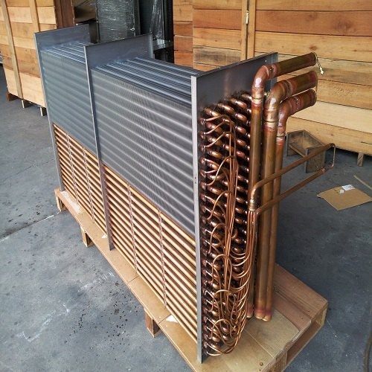
The evaporator, which collects heat from the area, and facilitates the boiling of the refrigerant

CONDENSER
The condenser, which dissipates heat into the ambient environment by allowing the refrigerant to return to a liquid state.
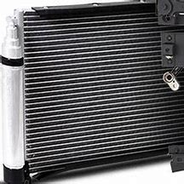

COMPRESSOR
The compressor, which is an electrical motor load and supplies the energy to drive the refrigerant through the system.
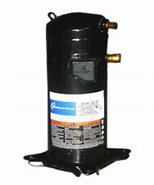

EXPANSION VALVE
The expansion valve, which acts as a regulator between the high and low pressure side of the system and allows for the drop in pressure and temperature necessary to facilitate DX cooling.
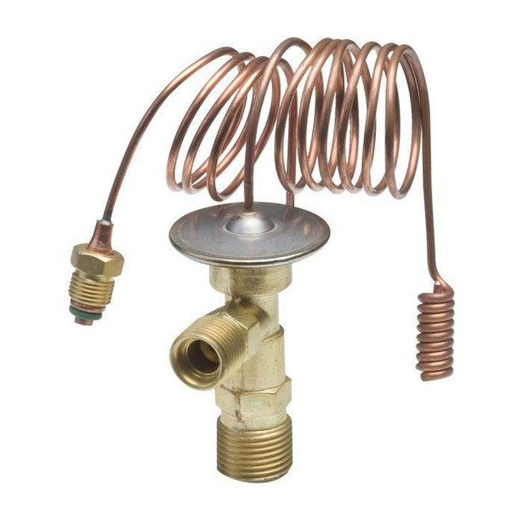

CPR Valve
Suction Filter
Suction Accumulator
Sight Glass
ACID Filter
Receiver

